**Topology (RIP V1)**

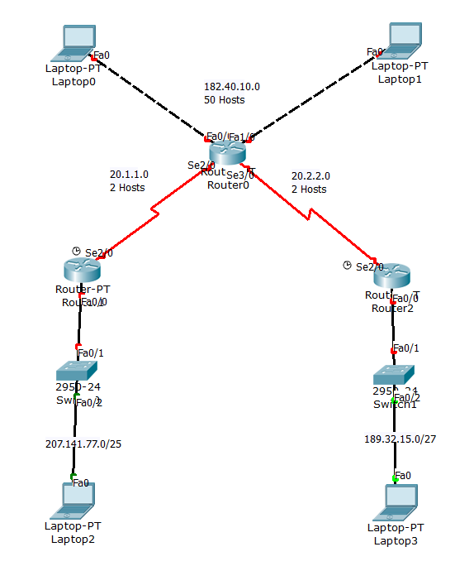

**Addressing Table**

|  |  |  |  |  |
| --- | --- | --- | --- | --- |
| **Device** | **Interface** | **IP Address** | **Subnet Mask** | **Default Gateway** |
|  |  |  |  |  |
|  |  |  |  |  |
|  |  |  |  |  |
|  |  |  |  |  |
|  |  |  |  |  |
|  |  |  |  |  |
|  |  |  |  |  |

**Configuring RIPv2**

|  |  |
| --- | --- |
| **Device** | **Command** |
| **R0** |  |
| **R1** |  |
| **R2** |  |